Shared Task Coordination Service (STCS)
Project: Phase 3 Report
Student: Sai Praneeth Bhattu
Course: CIS 527 - Computer Networks
Due Date: 11/3/2026

Table of Contents
1. Implementation overview 4
1.1 What Phase 3 delivers 4
1.2 Scope of this phase 4
1.3 Technology 4
1.4 Revised curiosity report 4
1.5 Final problem statement and value proposition 4
1.6 Final Functional and Non-Functional Requirements 5
2. Implementation architecture 6
2.1 Architecture diagram 6
2.2 Modules and responsibilities 6
2.3 Session state machine 7
2.4 Server control flow 7
3. Implementation details 7
3.1 Message framing 7
3.2 Strict JSON 8
3.3 Validation pipeline 8
3.4 Application logic 9
3.5 Server session handling and disconnect detection 9
3.6 Client 9
3.7 Resource cleanup 9
3.8 Concurrency design 9
3.9 Conflict behavior and error-handling strategy 10
4. Updated Protocol Specification - STCS - P3 10
4.1 Framing 10
4.2 Encoding and limits 10
4.3 Message envelope 11
4.4 Session states 11
4.5 Commands 11
4.5.1 HELLO 11
4.5.2 HELP 12
4.5.3 LIST_TASKS 12
4.5.4 CREATE_TASK 13
4.5.5 CLAIM_TASK 13
4.5.6 RELEASE_TASK 13
4.5.7 COMPLETE_TASK 14
4.5.8 DELETE_TASK 14
4.5.9 QUIT 14
4.6 Error codes 15
5. Data design 15
5.1 Task 15
5.2 Server data structures (Phase 3) 15
6. Sequence diagrams 16
6.1 Connection and HELLO 16
6.2 CREATE_TASK (valid, then invalid) 16
6.3 LIST_TASKS 17
6.4 CLAIM_TASK, including CONFLICT 17
6.5 Error and retry 18
6.6 QUIT and graceful close 18
6.7 Concurrent CLAIM_TASK (three clients, Phase 3) 19
7. Logging 19
7.1 What is logged 19
7.2 Privacy 19
7.3 Sample log 19
7.4 Logging under concurrency 20
8. Phase 3 testing 20
8.1 Approach 20
8.2 Results 21
8.3 Test report (detailed) 21
8.3.2 Unit and in-process protocol tests (34) and Integration tests over TCP (28) 21
8.3.3 Manual checks 22
8.3.4 Phase 2 deferred tests: now executed 22
8.3.5 Phase 3 concurrency and reliability tests (16) 23
8.3.6 Load test results 23
8.3.7 Extra checks 24
8.3.8 Final verification run and corrections 24
8.4 Limits of the testing 24
9. Design-change summary 25
10. Scalability analysis 25
11. Known limitations 26
12. Team contribution summary 27
13. Ripple Report Reflection 27

1. Implementation overview

1.1 What Phase 3 delivers
Phase 3 is the final form of STCS. Many clients connect to a single server over TCP at the same time and share the same task list. The server uses one thread per client and mutexes to protect the shared resources. It keeps serving other clients when one disconnects or sends invalid data.

1.2 Scope of this phase
- Networking: The server supports multiple clients and has been tested with up to 100 clients. The accept thread creates one worker thread per client.
- Protocol: The protocol is the same as in Phase 2. There is no server push, only request and response.
- Commands: All nine commands support simultaneous use by many clients. Claim, release, complete and delete commands are atomic.
- State: The task list, session registry and log are shared. There is a separate mutex for each of them.
- Logging: Logging is thread-safe, so log lines from different sessions do not get mixed. The log lines “connected” and “session released” allow counting the connected clients.
- Client user interface: The client user interface is the same as in Phase 2.
- Persistence: The tasks are still stored in memory only.

1.3 Technology
- Language: C++17 and the standard library. Compiled with g++ 13.3 using the -Wall -Wextra -Wpedantic flags to avoid warnings.
- Networking: Uses pure POSIX TCP sockets through the calls socket, bind, listen, accept, connect, send, recv, poll and close.
- Size: 4,400 lines of code, of which 1,659 are shared, 1,471 are server-side and 1,311 are client-side.
    - Compilation: A single Makefile with make targets: make, make tests, make check, make load, make clean. The executable files can be found at bin/server and bin/client.
    - Concurrency: Uses std::thread and std::mutex from the C++ standard library, compiled using -pthread. No external libraries are used.
    - Size of change in Phase 3: Approximately 100 lines changed in server/, 509 new lines for tests. The shared/ and client/ folders are unchanged.

1.4 Curiosity report
How can many people use one list through plain TCP without interfering with each other? At first, I assumed the issue would be with sockets. The solution was split into two phases. TCP is a byte stream protocol, so messages needed to be framed in Phase 2. Multiple clients can only be safely used if all check-then-change operations on shared state are atomic in Phase 3.

What I learned:
1) Adding threads was a minor change of about 100 lines, but proving the code correct was not. The test with 6 clients still passed without locking, since the race condition window is very small. ThreadSanitizer did point it out, so the tests prove the outcome and the race detector proves the reason.
2) Load testing was failing, because the server's console output pipe got blocked while the log mutex was held during the write. So logging is another example of shared state.
3) No changes were needed to the protocol and the framing, introduced in Phase 1 and 2.

Open question for the future is how this design would work with push notifications and many thousands of clients (section 10).

1.5 Problem statement and Value proposition
Problem: Small teams that use a list of work items, such as chatting and spreadsheets, often end up repeating themselves or relying on outdated data since there is no way to determine the owner of a particular task when two people attempt to perform it simultaneously.

Solution: STCS is a simple TCP-based server process that provides one consistent task list. Multiple clients can connect at the same time and insert, list, claim, release, finish and remove tasks. The number of clients is not fixed in the code: it depends on system resources such as memory, thread and file-descriptor limits, because the server uses one thread per client (Section 10). The server resolves any conflict by choosing the first claimant, who becomes the owner of the task.

Benefits: STCS provides a shared task list with one owner per task. It prevents duplicate claims, provides clear error messages and records user actions. If one client disconnects or sends invalid data, other clients can continue using the server.

1.6 Final Functional and Non-Functional Requirements

Functional requirements
ID | Requirement | Status | Test ID
FR-01 | The server shall listen on a TCP port supplied at startup, with no hard-coded port. | Implemented | T-01
FR-02 | The client shall connect to a hostname/IP and port supplied at startup. | Implemented | T-01, M-03
FR-03 | The client shall report a failed connection in plain language without crashing. | Implemented | T-07, T-08, T-08b
FR-04 | The server shall assign each connection a unique session ID and return it in the HELLO response. | Implemented | T-01, C-01
FR-05 | The client shall send HELLO with a display name as its first message and the server shall reject any other command before it with INVALID_STATE. | Implemented | T-01, X-05
FR-06 | The server shall create a task from CREATE_TASK, assign a unique task_id, set status OPEN and return the task. | Implemented | T-02
FR-07 | The server shall return all tasks with task_id, title, priority, status and claimed_by in response to LIST_TASKS. | Implemented | T-03
FR-08 | The server shall set a task to CLAIMED with the requester's name in response to CLAIM_TASK, only if it is currently OPEN. | Implemented | T-04, T-11 (C-04)
FR-09 | The server shall reject CLAIM_TASK on a task that is not OPEN with CONFLICT, naming the current owner, without changing the task. | Implemented | T-11 (C-04)
FR-10 | The server shall set a task to DONE in response to COMPLETE_TASK and reject a task already DONE with CONFLICT. | Implemented | T-04
FR-11 | The server shall remove a task in response to DELETE_TASK, after which it no longer appears in LIST_TASKS. | Implemented | T-04
FR-12 | The server shall maintain the task list for the lifetime of the server process, independent of any client session. | Implemented | X-04
FR-13 | A change committed by one client shall be visible to every other connected client on its next LIST_TASKS, with no client-side caching. | Implemented | T-10 (C-01 to C-03)
FR-14 | The server shall respond to an unknown command with UNKNOWN_COMMAND and continue serving the connection. | Implemented | T-05
FR-15 | The server shall respond to a missing required field with MISSING_FIELD naming the field and to an invalid value with INVALID_FIELD, without changing state. | Implemented | T-06
FR-16 | The server shall respond to a line that is not valid JSON, or is empty, with INVALID_MESSAGE and keep the connection open. | Implemented | T-06
FR-17 | The server shall respond to an operation on a non-existent task_id with NOT_FOUND. | Implemented | T-06
FR-18 | The client shall provide QUIT, which sends a QUIT request, closes the socket and exits with a confirmation. | Implemented | T-04
FR-19 | The server shall release a session's resources on both graceful and abrupt disconnection and continue accepting connections. | Implemented | T-09, T-09b, C-07
FR-20 | The server should serve at least three simultaneously connected clients. | Implemented | T-10 (C-01 to C-03)
FR-21 | A malformed message or failure in one session shall not terminate the server or affect other sessions. | Implemented | T-12 (C-08)
FR-22 | The server shall log, with timestamps startup, listening port, each connection with session ID, each command and its outcome, each error code, each disconnection and shutdown. | Implemented | Log inspection of docs/sample-server.log, R-04
FR-23 | The client shall list its supported commands when the user types help. | Implemented | U-C6
FR-24 | The server shall return a CLAIMED task to OPEN in response to RELEASE_TASK. | Implemented | T-04
FR-25 | The client shall validate input, namely non-empty title, integer task ID and valid priority, before sending. | Implemented | U-C5, X-08
FR-26 | The server shall allow LIST_TASKS to be filtered by status. | Implemented | T-03
FR-27 | The server shall restore the task list from a file on startup. | Not implemented future work | None R-03 shows an empty list after restart
FR-28 | The server shall push updates to clients without a request. | Not implemented future work | None

Non-functional requirements
ID | Requirement (original wording, Phase 1 report) | Status | Test ID
NFR-01 | The server shall continue processing subsequent requests after receiving an unsupported command from a connected client. | Met | T-05
NFR-02 | A malformed or oversized message from one client shall not terminate the server process. | Met | T-09, T-12 (C-08), U-I2
NFR-03 | For 20 repeated trials of two clients claiming the same task simultaneously, exactly one shall receive OK and the other CONFLICT and the task shall end with exactly one owner. | Met | T-11, C-04 with 30 races and exactly one OK each
NFR-04 | No response shall report OK for an operation whose change was not committed to the shared list. | Met | C-03, C-04 (indirect)
NFR-05 | The client shall display the list of supported commands when the user requests help, without needing a server connection. | Partially met: help works only after connecting (Known Limitation f) | U-C6 for help forms
NFR-06 | Every error shown to the user shall include a human-readable sentence in addition to the error code and shall contain no stack trace, file path, or line number. | Met | T-06, U-C3, U-D7
NFR-07 | Invalid input at a client prompt shall cause a re-prompt naming the expected format and shall never terminate the client. | Met | X-06, X-08, U-C5
NFR-08 | With up to 3 clients and up to 200 tasks, the server shall return a response within 100 ms of receiving a complete request, on localhost. | Met | M-01: manual and limited slowest 0.85 ms
NFR-09 | The client shall detect an unreachable server and report it within 10 seconds rather than blocking indefinitely. | Met within tolerance: 10 s timeout, measured 10.012 to 10.015 s (section 8.3.3) | T-07, T-08, M-02
NFR-10 | The server shall support at least three simultaneously connected clients in Phase 3. | Met | T-10 (C-01 to C-03) load test up to 100 clients
NFR-11 | Per-client memory shall be bounded by a receive buffer of at most 8 KiB plus the session record, so memory grows linearly with the number of clients. | Met: buffer bounded about 24 KB resident per idle client, linear growth (section 10) | U-F4, U-F5
NFR-12 | Networking, framing, protocol validation, application logic, data, user interface and logging shall each reside in a separate module. | Met | Inspection (section 2.2)
NFR-13 | The framing layer shall be testable without a socket, through an interface that accepts arbitrary byte chunks and emits complete messages. | Met | Suite 1: T-13a/b, T-14a/b, U-F1 to U-F8
NFR-14 | The server shall validate the type, length and range of every received field before use and shall reject any line longer than 8192 bytes. | Met | U-F3, U-V1 to U-V3, U-E1, U-I2
NFR-15 | Display names shall be documented as identification only, not authentication. | Met, documented in README and Known Limitation c | None documentation
NFR-16 | All client output shall be plain text within 80 columns, with no information conveyed only by colour and no prompt shall expire. | Met | U-C1, U-C3

2. Implementation architecture

2.1 Architecture diagram
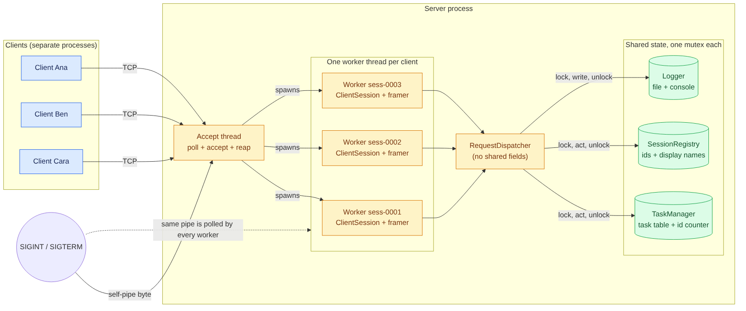
Figure 1. STCS Phase 3 architecture: Multiple clients, one server

2.2 Modules and responsibilities
Dir | Module | Responsibility
shared/ | net | RAII socket, send_all that handles partial sends, peer address, SIGPIPE handling.
shared/ | framing | MessageFramer: buffers bytes, extracts lines, bounded memory, resynchronises.
shared/ | json | Strict RFC 8259 parser and serializer.
shared/ | utf8 | UTF-8 validation, code-point counting, safe truncation.
shared/ | protocol | Constants, commands, error codes, envelope, Task type.
shared/ | validation | Display name, title, port and task-id rules.
shared/ | timeutil | ISO-8601 UTC timestamps.
server/ | server | Listener, accept loop that starts one worker thread per client, per-session receive loop, disconnect detection, joining of finished threads, shutdown via self-pipe.
server/ | dispatcher | Validation order, one handler per command, replies and logs.
server/ | request_validation | Payload field readers such as read_title and read_task_id.
server/ | task_manager | Task store: create, list, claim, release, complete, delete. One mutex makes each method one atomic check-then-act unit across all clients.
server/ | session | ClientSession, which is one per thread and never shared and SessionRegistry, which handles ids and name uniqueness and has its own mutex.
server/ | logger | Timestamped log to file and terminal. One mutex keeps lines whole. Sanitises client text.
client/ | connection, input_parser, display, client_app | Connect, parse input, display output, session loop.

2.3 Session state machine
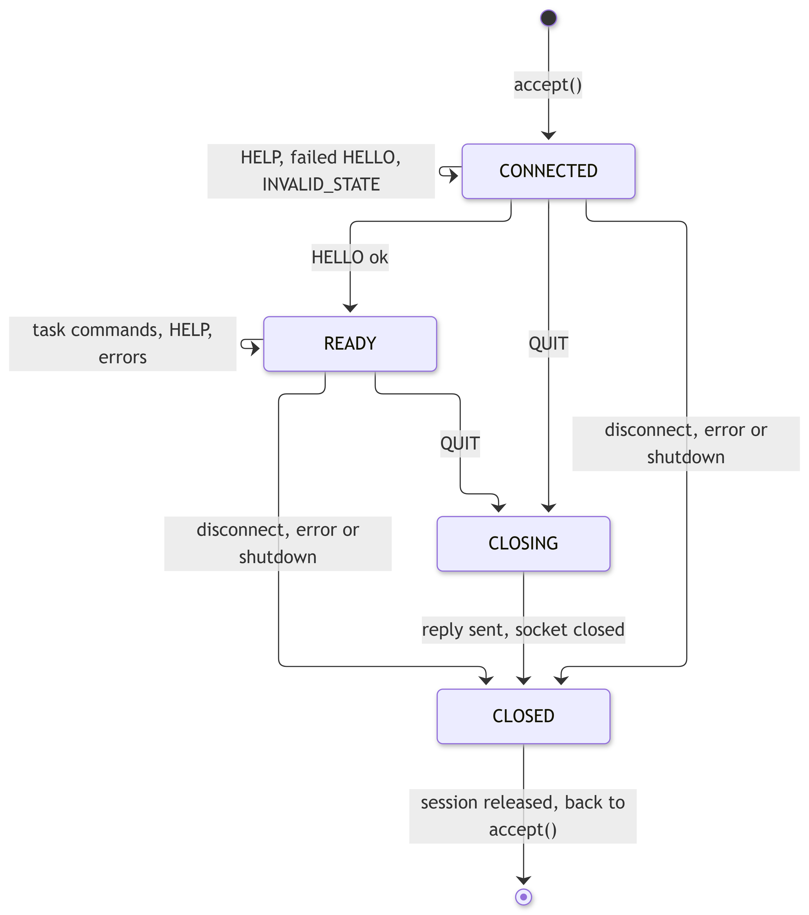

Figure 2. Session states

2.4 Server control flow
- The server implements one accept thread and one worker thread per client:
- start (): Create the wake-up pipe, then call socket (), set SO_REUSEADDR, bind to 0.0.0.0: port, listen with backlog of 128 and printf("Server listening on 0.0.0.0: PORT").
- run () in the accept thread: poll () the listening socket and the wake-up pipe with 1-second timeout. Upon readiness of the listener, accept () the connection, create and start a worker thread. Join the threads of disconnected clients.
- serve_client() in the worker thread: create the ClientSession, register and log it. Then, in a loop: poll () the client socket and the wake-up pipe, receive up to 4096 bytes, pass the data to the framer, execute the dispatcher for every frame and send back the response with send_all(). Exit the loop if the client sent QUIT, receive returns 0, get some other error or has been shut down. If an exception occurs within a session, only that session is stopped.
- Log the disconnect message according to the cause, which is either "disconnected gracefully" or "disconnected unexpectedly". Close the socket, un-register the session and its display name, stop the thread. The other threads will not be impacted.
- SIGINT/SIGTERM signal handler writes one byte into the wake-up pipe. The byte is never read, so every poll () in all threads detects it. All workers close their session and log "closed by server shutdown". The accept thread stops, waits for all workers, prints "Shutdown requested" and "Server shutdown complete" and terminates with code 0.

3. Implementation details

3.1 Message framing
TCP is a byte stream, so one send () is never assumed to equal one recv(). Each side owns a MessageFramer. Every recv() appends its bytes to the framer the program then asks for frames until none is left:
char chunk[4096]
n - recv(fd, chunk, sizeof chunk, 0)
framer.feed(chunk, n)
while (framer.next_frame(frame)) {
handle(frame)
}
- A line is the bytes up to a newline, except for the trailing carriage return. If the newline has not arrived yet, the line stays in the buffer until it does.
- If there are multiple lines in one read operation, they are returned one after the other. Everything left is stored in the buffer.
- An empty line is represented as Blank and the response from the server is INVALID_MESSAGE.
- If a line is larger than 8192 bytes, the TooLarge status is reported, with a MESSAGE_TOO_LARGE reply from the server and everything up to the next newline is discarded. Normal framing resumes afterwards. An oversized line is reported as soon as the buffer exceeds 8192 bytes without a newline, and the buffer is then cleared, so the memory used per session stays bounded (NFR-11). An incomplete message of 8192 bytes or fewer, with no newline yet, is not reported: it remains buffered until its newline arrives.
- Outgoing messages have all control characters escaped, so a message can never contain a newline. Otherwise, an exception is thrown.
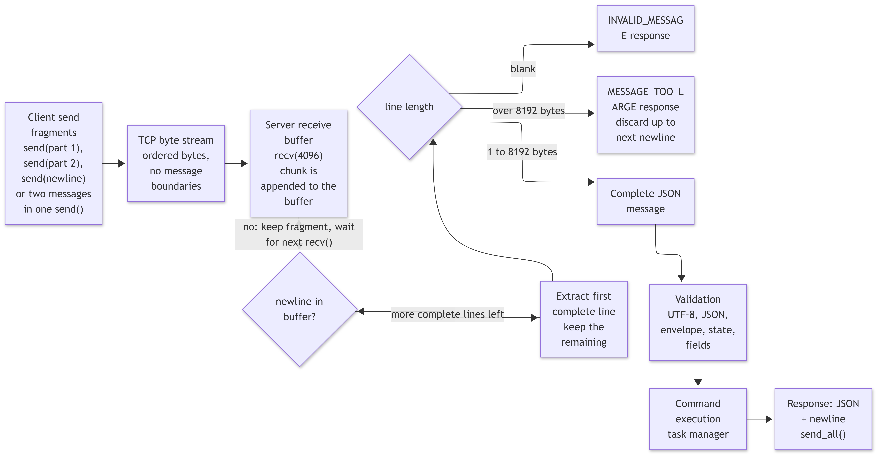
Figure 3. Framing and validation pipeline

3.2 Strict JSON
I wrote a small JSON parser and serializer instead of using a library. It follows RFC 8259, validates UTF-8, decodes pairs, rejects duplicate keys and trailing commas, limits nesting to 32 levels and keeps integers separate from floats so task_id: 7.0 is not accepted as an integer.

3.3 Validation pipeline
RequestDispatcher:handle_frame() performs the checks in a fixed order and stops at the first failure. The order is given in the spec (Section 4.3):
- The input must be valid UTF-8 and JSON object or there will be an INVALID_MESSAGE response, in which request_id and command are null.
- version: If missing, it's MISSING_FIELD if not an integer INVALID_FIELD if not equal to 1 INVALID_VERSION and the payload includes supported_versions.
- type must be a string "REQUEST", where missing gives MISSING_FIELD and other values give INVALID_FIELD.
- request_id: If missing MISSING_FIELD if not a string of 1-64 bytes INVALID_FIELD.
- command: If missing MISSING_FIELD if not a string INVALID_FIELD if not in the list UNKNOWN_COMMAND.
- payload must be a JSON object.
- Check for session state, where a command which isn't allowed for the current state yields an INVALID_STATE response.
- Validation of fields from payload, which yields MISSING_FIELD or INVALID_FIELD.
- Execution, which yields NOT_FOUND, CONFLICT or OK.

3.4 Application logic
The Task Manager is unaware of sockets and JSON. All public methods, namely create, list, claim, release, complete and delete, read the task object, verify its state and write it back to the storage atomically. These methods return one of Ok, NotFound or Conflict states together with the task object. In case of Conflict, nothing is changed in the task object. Task IDs are assigned incrementally using a never-ending counter. Phase 3: all public methods first acquire the manager mutex, so that no other thread will be able to interfere between verification and modification. List methods copy the list objects while holding the mutex and then send them once the mutex is released.

3.5 Server session handling and disconnect detection
- recv() returning 0 indicates the client disconnected without QUIT the server reports "disconnected unexpectedly (connection closed without QUIT)", might report "N bytes of an incomplete message discarded" if a fragment still exists at the framer level and frees the session. A failed recv(), such as a reset, would be reported as a receive error.
- After QUIT, the reply is sent, the state transitions to CLOSING, "disconnected gracefully" is reported and the socket is closed. Each case ends with "session released".
- SIGPIPE is ignored and send_all uses MSG_NOSIGNAL, so writing to a closed connection returns an error and does not kill the server.
- Several clients can be connected at the same time. Each has its own thread.

3.6 Client
- connection: make use of getaddrinfo and a non-blocking connect() with poll(), as well as a 10 second timeout overall (NFR-09). Provide helpful information in case connections are rejected, do not resolve or timeout. Gracefully close with shutdown(SHUT_WR).
- input_parser: perform local checks before submitting, such as for an empty line, unknown verb, task id and list filter.
- client_app: automatically submit HELLO request and in case of NAME_IN_USE or an invalid name retry with another one, then loop to accept requests. Every request has its own request_id, and a response with a different id is treated as a protocol error. Reprompt on invalid title or priority /cancel command ends the session. End of input is treated as quit.
- display: wrap tables and messages to 80 columns. Display all errors in format of "Error [CODE]: sentence" and additional message, don't ever show a stack trace or a path (NFR-06, NFR-16).
- The raw command for developers allows sending any COMMAND with a JSON payload for testing purposes in case of server side error, such as an unknown command or unknown field.

3.7 Resource cleanup
Each worker thread manages its own session and socket. RAII handles socket cleanup when a session ends, whether through QUIT, disconnection, an error or server shutdown. The accept thread waits for all worker threads to finish before exiting. The log file is flushed after each entry.

3.8 Concurrency design
Design choice. One thread per client. The Phase 2 code already had a loop for each session, so each loop was turned into its own thread with minimal changes. This means one slow client does not affect the others, and the approach is easy to follow. Thread pools cannot be used here because sessions are long running. A poll/epoll event loop would require converting the session loop into a state machine. One thread per client is enough for tens of clients.

Session structure. The ClientSession object is created by the worker thread. It holds the session id, such as sess-0001, the peer address, display name, session state and a framer buffer. It is owned by that thread and is never shared. The SessionRegistry only contains session id and display name.

Shared objects and synchronization. Every shared object has one std::mutex and each function locks it with std::lock_guard for the duration of the function:
Data | C++ type | Shared? | Protection | Operations
Task table, next_task_id_ | std::map<long long, Task>, long long | All workers | TaskManager mutex | create, list, claim, release, complete, delete
Session ids, display names | std::map<string, string>, unsigned | All workers | SessionRegistry mutex | next id, add, reserve name, remove
Log file and console | std::ofstream, std::cout | All threads | Logger mutex | every log line
ClientSession, framer buffer, socket | struct, std::string, Socket | One worker only | Not needed | not shared
Worker list | std::list<{thread, atomic done}> | Accept thread only | Atomic flag | start, join
Wake-up pipe | fd pair | Signal handler writes, all poll | One-byte write | shutdown
Locks and deadlocks. A thread never holds two locks at the same time. The dispatcher calls TaskManager, SessionRegistry and Logger one by one, and they do not call each other while locked, so a circular lock dependency cannot happen. No lock is held during recv() or send(). One lock per object is intentionally simple. Operations take only a few microseconds and tasks are very small, and the load test shows where contention appears.

Cleaning up. See 3.7. Shutdown uses self-pipe from 2.4.

3.9 Conflict behavior and error-handling strategy
Situation | Defined result | Test
Two clients claim the same task | One gets OK. The others get CONFLICT naming the owner. Task unchanged. | C-04
Two clients HELLO with the same name | One gets OK. The others get NAME_IN_USE. | C-06
One client deletes a task another is viewing | The next action on it gets NOT_FOUND. The viewer's old list is only a snapshot. | C-05
Two clients complete the same task | First gets OK, second gets CONFLICT as it is already DONE. | R-01
Clients create tasks at the same time | Ids are unique and never reused. | C-03
A client disconnects while holding claims | Tasks stay CLAIMED and any client may release them. The name is freed. | C-07
A client dies in the middle of a message | The fragment is discarded and logged. Others are unaffected. | C-07, T-09b
A client sends invalid or malformed data | Structured ERROR to that client only. The session continues. | C-08
1) Framing: an empty line gets invalid_message, while an oversized line gets message_too_large.
2) The envelope and payload are validated in a fixed sequence.
3) First state, then execution is validated and an error may result in not_found or conflict.
4) Internal errors: all exceptions are caught by the dispatcher and generate server_error, while serve_client() deals with everything else.
5) Networking errors: a failed recv() or send() aborts the session and is logged.
6) A failed thread initialization rejects only the newly connecting client. No message contains any path or stack trace and all errors are logged along with the session id.

4. Updated Protocol Specification - STCS - P3
This section supersedes Phase 1, section 7 as the deployed protocol. This is the same protocol, STCS v1. The differences are that the ambiguities from Phase 1 have been resolved, and they are listed in section 9 with IDs C-1 to C-12. All the example data below comes from the live server as recorded in docs/protocol-examples.json, although it is formatted in sections here for readability. Each example is sent as one line.

4.1 Framing
Framing rule: A message consists of a single JSON object encoded in UTF-8. It does not contain a raw newline and is terminated by a single newline. The receiver reads bytes until a newline arrives, then processes the message. It processes later lines in order as they arrive and may hold an incomplete line at the end. There is no sleep between messages.

4.2 Encoding and limits
Property | Value
Encoding | UTF-8, no BOM
Delimiter | \n
Max request size | 8192 bytes per line
Max response size accepted by the client | 1 MB
Receive chunk | 4096 bytes per recv()
Timestamps | ISO-8601 UTC
Request id | string of 1-64 bytes
JSON nesting depth | at most 32
An oversize line is answered with one MESSAGE_TOO_LARGE. The bytes up to the next newline are discarded and the stream resynchronizes.

4.3 Message envelope
Request
Field | Type | Required | Notes
version | integer | yes | 1
type | string | yes | "REQUEST"
request_id | string | yes | 1-64 bytes client-generated, unique per session, echoed back unchanged
command | string | yes | One of the nine commands
payload | object | yes | {} when the command takes no arguments
Response: Sends back the same version but with "RESPONSE", and the request_id and command, or null if they could not be found. It also has status, which is "OK" or "ERROR", and payload. In case of error, it also has error_code and a description of it.
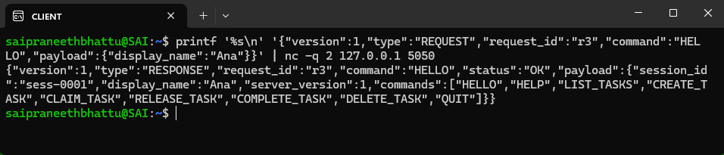
Order of validation, where the first failing check decides the reply:
Versioning: only version 1 is supported. If the version is absent, the error is MISSING_FIELD. If the version field is not an integer, the error is INVALID_FIELD. Otherwise, the error is INVALID_VERSION with supported_versions. The client creates request ids and the server returns them unchanged. A response with a different id is a protocol error for the client. Notifications: none. Each server message responds to one request.
Client update protocol in Phase 3: request and response. A client learns about changes made by others only when it sends LIST_TASKS. The server never sends a message without a request.

4.4 Session states
State | Legal commands
DISCONNECTED | none, as there is no socket
CONNECTED | HELLO, HELP, QUIT. Anything else returns INVALID_STATE
READY | all task commands, HELP, QUIT. A second HELLO returns INVALID_STATE
CLOSING, CLOSED | none, the socket is closed and the session is released
A failed HELLO leaves the session in CONNECTED. An INVALID_STATE error never closes the connection. Figure 2 (section 2.3) shows the state transitions.

4.5 Commands
Every task payload uses the task object defined in section 5.1.
Unless noted, every command is sent by the client, received by the server dispatcher and allowed only in READY, while HELLO, HELP and QUIT list their own state. Every command may also return the envelope errors INVALID_MESSAGE, INVALID_VERSION, MISSING_FIELD, INVALID_FIELD, UNKNOWN_COMMAND, MESSAGE_TOO_LARGE and SERVER_ERROR, as well as INVALID_STATE.

4.5.1 HELLO
Purpose | Registers the client's display name and moves the session from CONNECTED to READY.
State | CONNECTED only, as a second HELLO returns INVALID_STATE.
Fields | display_name is required and is a string. No optional fields.
Validation | 1-24 characters, only ASCII letters, digits, space, _, -, . Not starting/ending with space, must not be equal, using a case sensitive match, to the name of another active session.
Behavior | On success, session status changes to READY and name is reserved until session is released. On failure of HELLO, the session remains in CONNECTED state so that the client can try again with a new name.
Success response | Session id, which is a string such as "sess-0001", display name, server version, which is 1 and commands, which is an array of 9 command names.
Errors | NAME_IN_USE
Example success response:
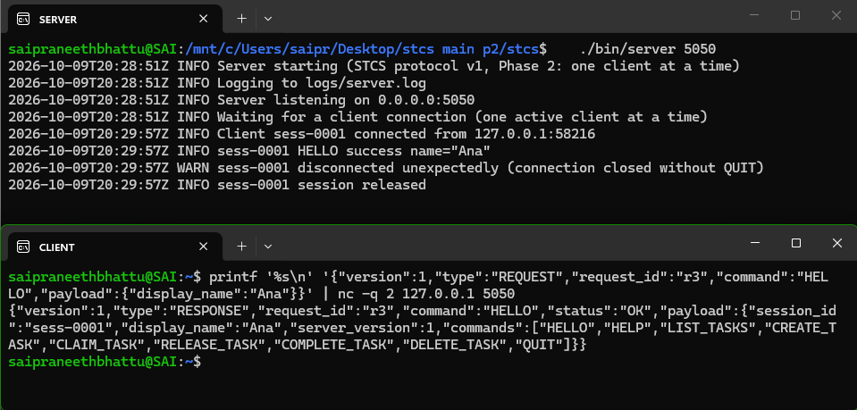
Example error responses:

4.5.2 HELP
Purpose | Returns the server's command list or the entry for one command.
State | CONNECTED or READY.
Fields | command is optional and is a string. No required fields.
Validation | If present, command must be one of the nine command names, with an exact upper-case match.
Behavior | Read-only. Without command the reply lists all nine commands in protocol order.
Success response | commands: array of objects with name, summary, required_fields.
Errors | INVALID_FIELD when command is not a string or not a known command name.
Example request & response:
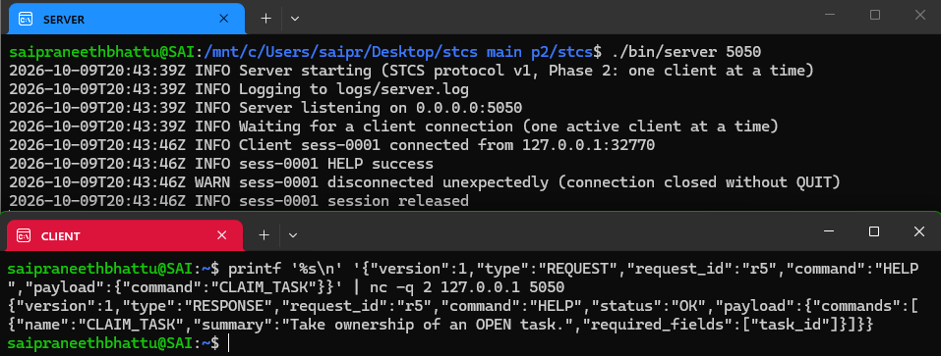

Example error response:
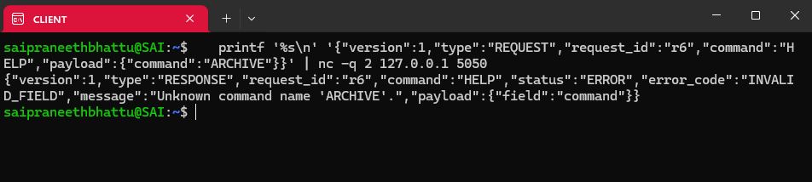

4.5.3 LIST_TASKS
Purpose | Returns the shared task list the way every client sees the current server state.
Fields | status is optional and is a string. No required fields.
Validation | If present, status must be exactly OPEN, CLAIMED or DONE.
Behavior | Read-only. Tasks are returned in ascending task_id order. The reply line can exceed 8192 bytes for large lists (see clarification C-1).
Success response | tasks, which is an array of Task and count, which is an integer.
Errors | None beyond the common errors.

Eample request and response:
Example error response:
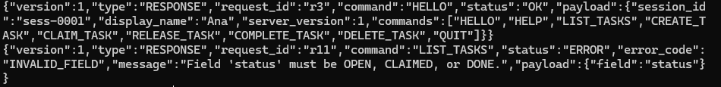

4.5.4 CREATE_TASK
Purpose | Adds a task to the shared list.
Fields | title is required and is a string. priority is optional and is a string with the default MEDIUM.
Validation | After trimming ASCII whitespace, 1-120 Unicode code points, not blank, no control characters. priority: exactly low, medium or high.
Behavior | The server assigns task_id from a counter that is never reused, sets status OPEN, claimed_by null, created_by as the session's display name and created_at as the server UTC time. The trimmed title is stored.
Success response | task, which is the full Task object.
Errors | None beyond the common errors.
Example success response Example error responses:

4.5.5 CLAIM_TASK
Purpose | Takes visible ownership of an OPEN task so that nobody duplicates the work
Fields | task_id is required and is a JSON integer. No optional fields.
Validation | A JSON integer ≥ 1. Strings, even "7", floats, booleans and null are rejected with INVALID_FIELD. The task must exist and its status must be exactly OPEN.
Behavior | In one check-then-act step the task manager re-reads the task, checks OPEN and sets status CLAIMED and claimed_by - the session's display name. A task that is not OPEN is left unchanged.
Success response | task, which is the full Task object.
Errors | NOT_FOUND CONFLICT, whose payload is task_id, current status and claimed_by when owned
Example success response:
Example error responses:

4.5.6 RELEASE_TASK
Purpose | Returns a CLAIMED task to OPEN so that someone else can take it.
Fields | task_id is required and is a JSON integer. No optional fields.
Validation | JSON integer ≥ 1. The task must exist and be CLAIMED. Any session may release any claimed task (Phase 1 open question Q2), and the releasing user is the released_by value.
Behavior | Sets status OPEN and claimed_by null.
Success response | task, which is the full Task object and released_by, which is a string.
Errors | NOT_FOUND CONFLICT when the task is not claimed
Example request & response:
Example error response:

4.5.7 COMPLETE_TASK
Purpose | Marks work finished so the remaining-work view stays accurate.
Fields | task_id is required and is a JSON integer. No optional fields.
Validation | JSON integer ≥ 1. The task must exist and be OPEN or CLAIMED.
Behavior | Sets status DONE and keeps claimed_by as the record of who did the work. A task completed directly from OPEN keeps claimed_by null.
Success response | task, which is the full Task object.
Errors | NOT_FOUND CONFLICT when the task is already DONE
Example request & response:
Example error response:

4.5.8 DELETE_TASK
Purpose | Permanently removes an obsolete task so the list stays trustworthy.
Fields | task_id is required and is a JSON integer. No optional fields.
Validation | JSON integer ≥ 1. The task must exist. A task in any status may be deleted.
Behavior | Removes the record. The id is never reused.
Success response | task_id, which is an integer and deleted, which is true.
Errors | NOT_FOUND
Example request & success response:
Example error response:

4.5.9 QUIT
Purpose | Ends the session gracefully so the server can log a clean disconnect and release resources.
State | CONNECTED or READY.
Fields | reason is optional and is a string. No required fields.
Validation | If present, reason is a string of at most 200 bytes. It is logged only in sanitised form, never stored.
Behavior | The server returns the response, changes the status of the session to CLOSING, closes the socket, releases the session and its display name, logs “disconnected gracefully,” and terminates the session thread. Claims made by the session remain (Q2). An invalid QUIT returns an error and does not end the session.
Success response | message, which is "Session closed." and session_id.
Errors | INVALID_FIELD for a bad reason. Envelope errors as for every command.
Example request & response:

4.6 Error codes
Code | When generated | Payload
INVALID_MESSAGE | The message is not valid UTF-8 JSON, is not a JSON object, or is empty. | None, as request_id and command are null
INVALID_VERSION | version is an integer other than 1. | {"field": "version", "supported_versions": [1]}
UNKNOWN_COMMAND | The command is not one of the supported commands. | {"field": "command"}
MISSING_FIELD | The envelope or payload field is missing. | {"field": name}, name = the missing field
INVALID_FIELD | The field is of the incorrect type, length or value. Also generated if the version is not an integer. | {"field": name}, name = the invalid field
NOT_FOUND | The provided task_id is unknown. | {"task_id": n}
CONFLICT | Conflict between the request that was made and the task state. For example, claiming a task that is not OPEN, releasing a task that was not claimed or completing a task that is already done. | task_id, status and claimed_by when owned
INVALID_STATE | Command is not available in the current session state. For example, sending a command in a state where none is allowed, or sending a second HELLO. | {"state": ...}
NAME_IN_USE | Display name is used by some other active session. | None
MESSAGE_TOO_LARGE | Length of the request line exceeds 8192 bytes. | None
SESSION_ERROR | Session cannot be continued. | None, see the note below
SERVER_ERROR | Unexpected server error occurs in processing a valid request. | None, with details in the server log only
Note: SESSION_ERROR is defined but not used in Phase 3 (see C-8).

No error message contains a stack trace, file path, line number or internal identifier. NOT_FOUND means the task does not exist. CONFLICT means it exists but its state does not allow the operation.

5. Data design
The data design of Phase 1 section 8 is implemented as specified. This section records how each structure appears in the code.

5.1 Task
Field | Type | Mutable | Implementation
task_id | integer ≥ 1 | No | Assigned from next_task_id_ never reused
title | string | No | Stored trimmed 1-120 code points no control characters
priority | LOW, MEDIUM, HIGH | No | Default MEDIUM
status | OPEN, CLAIMED, DONE | Yes | Changed by claim, release, complete only
claimed_by | string or null | Yes | Display name kept when the task becomes DONE
created_by | string | No | Display name of the creating session
created_at | ISO-8601 string | No | Server UTC clock

Server data structures (Phase 3)
Server data structures and their protection are listed in Section 3.8.

6. Sequence diagrams

6.1 Connection and HELLO
Figure: Connection and HELLO

6.2 CREATE_TASK (valid, then invalid)
A valid task is committed and logged. A request with a missing title is rejected with no state change.
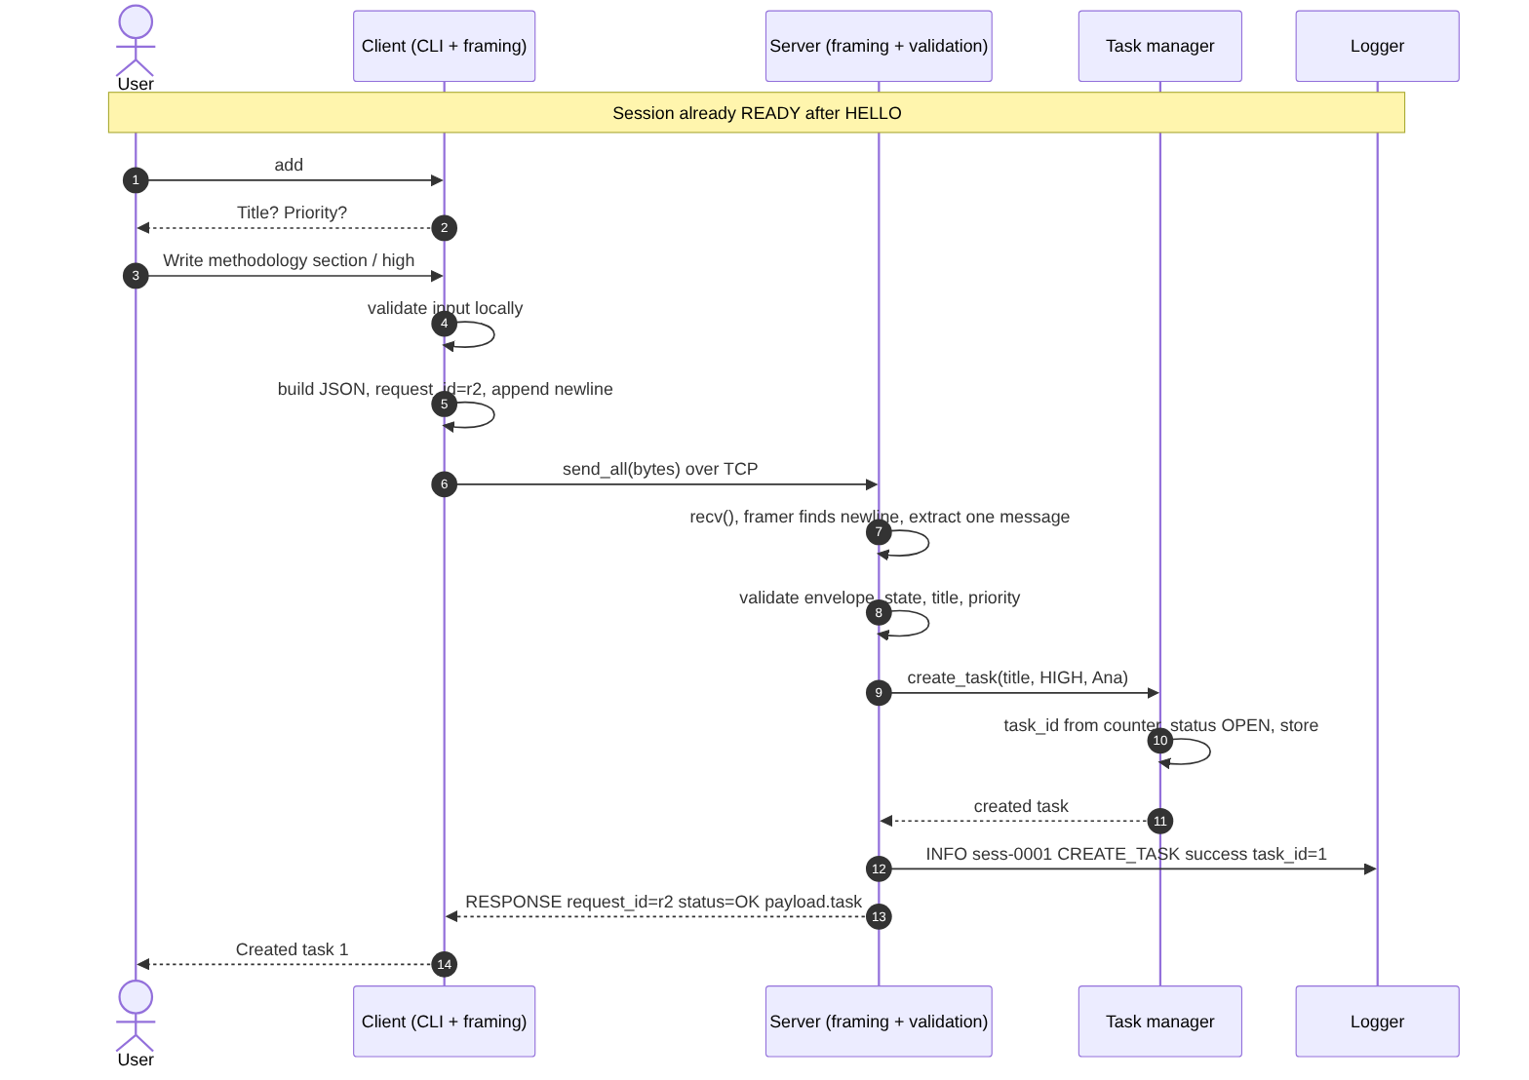
Figure: CREATE_TASK (valid, then invalid)

6.3 LIST_TASKS
The client holds no list. Every display comes from a fresh reply.
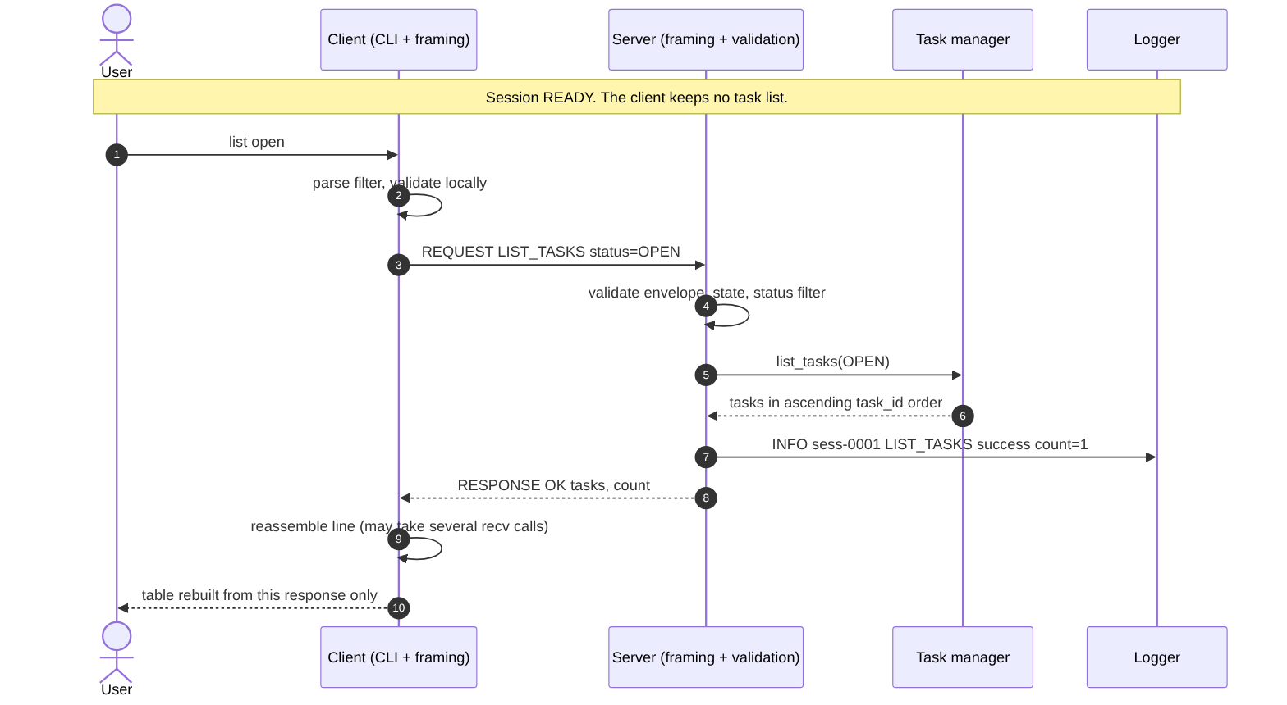
Figure: LIST_TASKS

6.4 CLAIM_TASK, including CONFLICT
The claim succeeds when the task is OPEN. A second claim on the same task returns CONFLICT with the current owner and changes nothing.
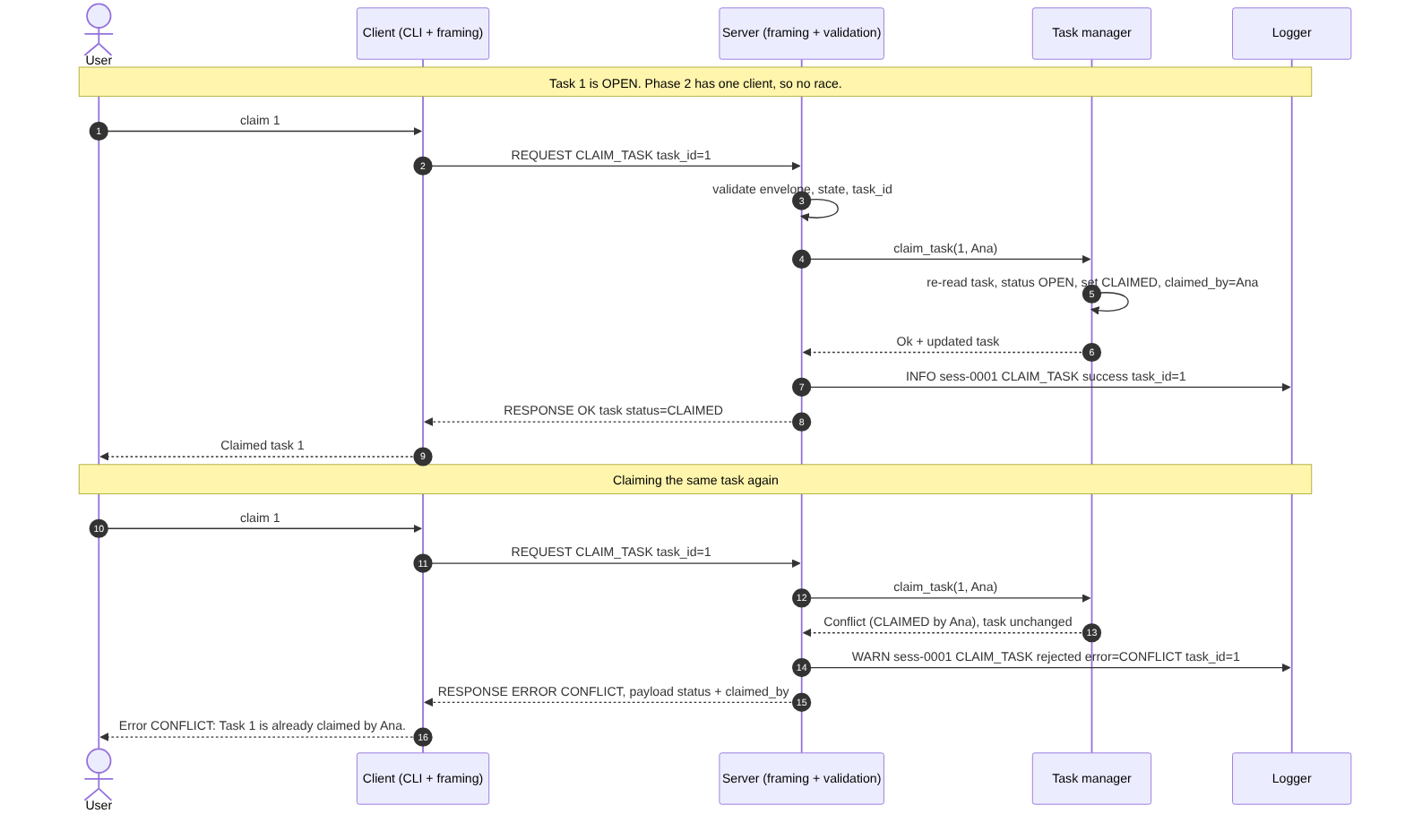
Figure: CLAIM_TASK, including CONFLICT

6.5 Error and retry
An unknown command and a missing field are rejected with structured errors and the session continues.
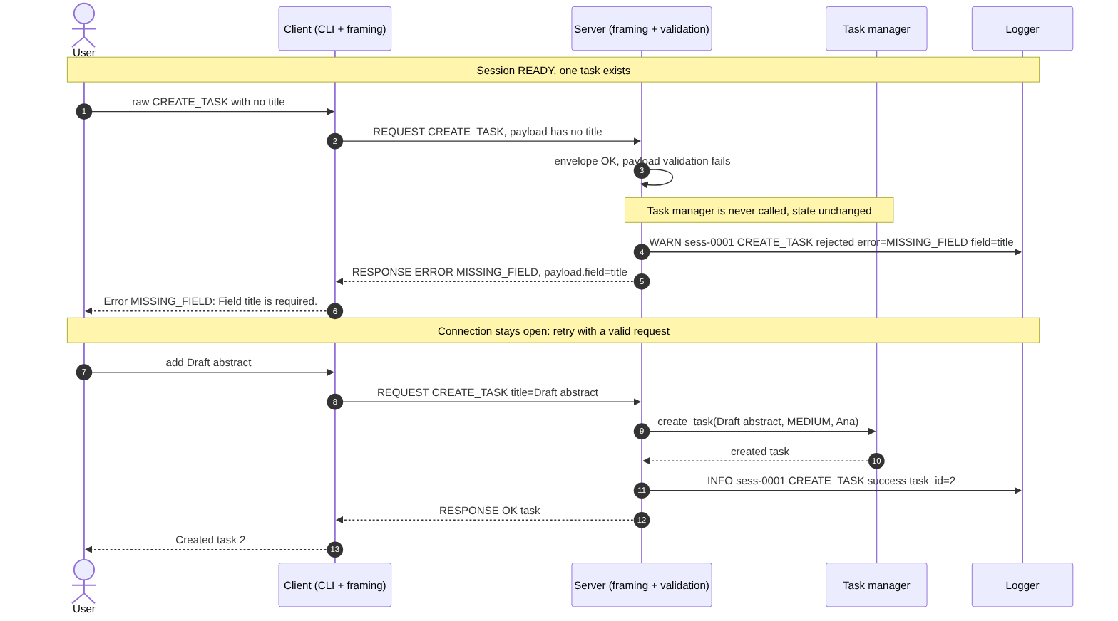
Figure: Error and retry

6.6 QUIT and graceful close
The server replies, closes the socket, releases the session and returns to listening.
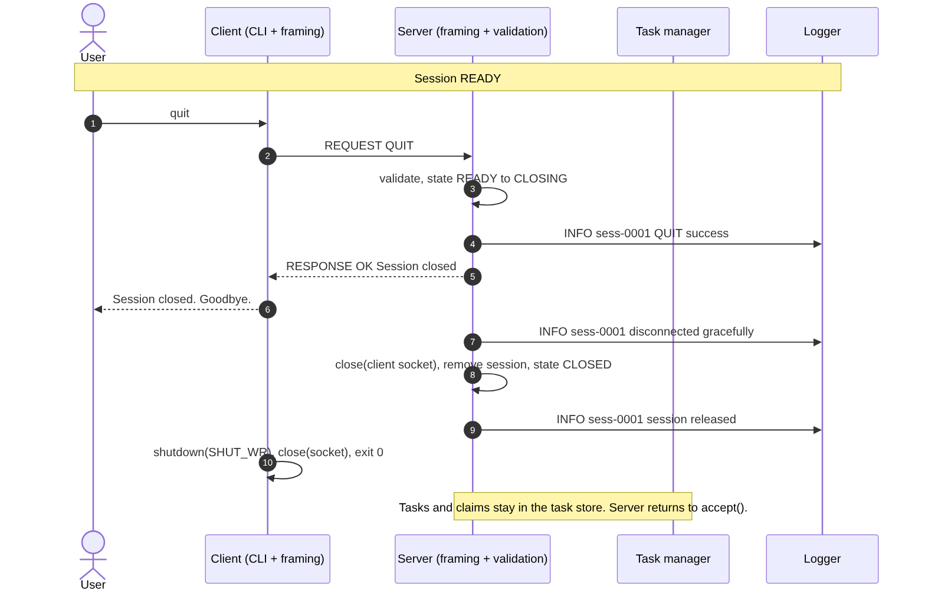
Figure: QUIT and graceful close

6.7 Concurrent CLAIM_TASK (three clients, Phase 3)
Three clients send CLAIM_TASK for the same task at the same time. The server threads synchronize using the TaskManager lock. The first thread modifies the task and the other two see it as CLAIMED. Every client receives only one response.
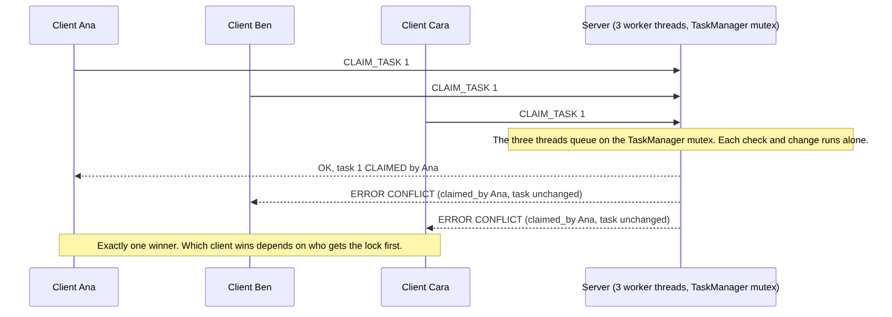
Figure: Concurrent CLAIM_TASK, three clients and one task

7. Logging

7.1 What is logged
Logged events: server startup, client connection, request outcome, rejected request, envelope or protocol error, graceful disconnect, abrupt disconnect, session release and server shutdown. The sample log in Section 7.3 shows each of these.

7.2 Privacy
Task titles are not logged. Display names and QUIT reasons are logged, but only after sanitising: control characters become ‘?’ and long text is truncated, with QUIT reasons truncated to 60 characters.

7.3 Sample log
Ana, Ben and Cara are online simultaneously.
Ana creates two tasks.
Ben takes Task 1 and Cara’s attempt to take Task 1 is denied with CONFLICT.
Ben issues an incorrect request.
Cara is terminated without issuing a QUIT.
Then both Ana and Ben continue and quit and the server is terminated with SIGTERM.
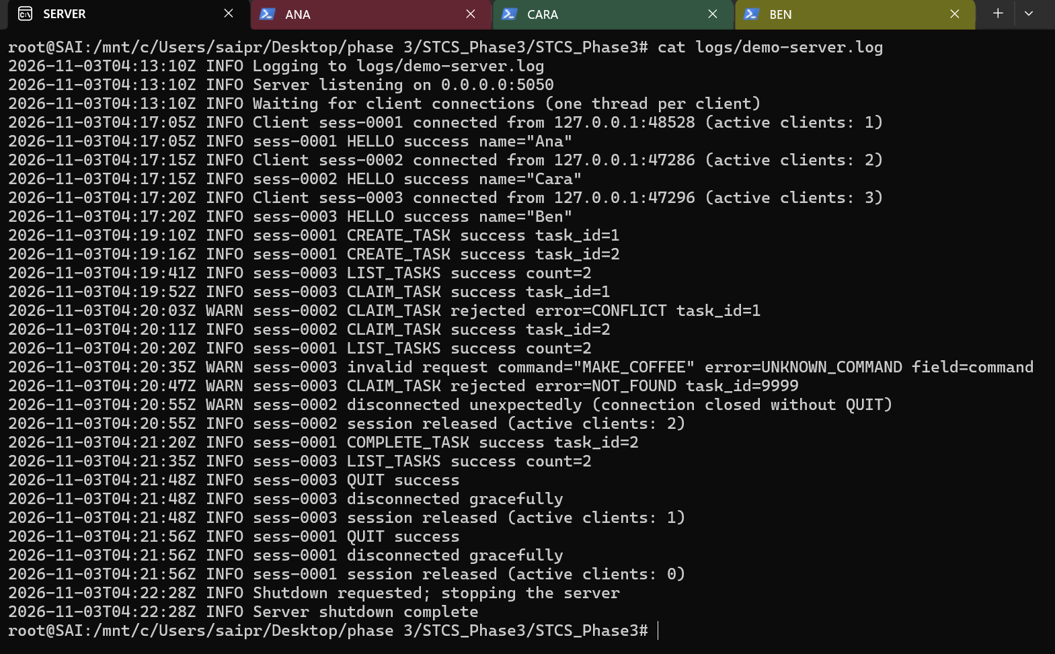

7.4 Logging under concurrency
All log calls use the same mutex so that each line is fully written. Test R-04 runs four clients concurrently, produces exactly 100 successful CREATE_TASK lines and checks that every line starts with the timestamp. Every line contains the session id, so the history of any client can be traced with grep.

8. Phase 3 testing

8.1 Approach
- Five suites of automated tests are run with make check. Suite 1 is framing unit testing without sockets. Suite 2 is unit and in-process protocol testing that covers JSON, validation, envelope, task manager, registry, dispatcher, and client input and display. Suite 3 is integration testing that runs the real bin/server and bin/client, as in Phase 2. Phase 3 also adds concurrency and reliability testing with several clients at once (suite 4) and load testing (suite 5).

- Tests wait for events such as a log line, a response or EOF instead of using fixed delays. The only fixed timer is a watchdog, which stops a test if a process freezes. It allows 15 seconds per read and 300 seconds per test. In Phase 3, the exceptions are C-01, C-06 and C-11, which use a 1 ms sleep to keep a connection alive or to wait between message parts. Timing does not affect any result.

- Controlled splits. Unit tests use exact chunk boundaries. In socket tests, each send () call is used, but TCP may merge small writes. So these tests check that the result is correct, with one response per request, in order and with no duplication, instead of checking the sequence of reads. Both levels are reported independently.

- IDs. IDs of Phase 1 tests are unchanged (T-01 to T-14). Variants have a suffix: a/b for framing unit halves, u for the in-process version, b/c for the additional scenario and command-line client. Additional tests for Phase 2 are U- for unit/in-process and integration helper tests, X- for additional scenarios. The new test is T-17, which is "server disappears".

- Phase 3 test cases. Suite 4, test_concurrency, starts a real server and runs it with several client threads at the same time. The IDs C-01 through C-12 are concurrency test cases and R-01 through R-04 are reliability test cases. Suite 5, load_test, is the load test. Test case X-01 is revised because a second client is now served at the same time.

8.2 Results
Suite | Executed | Passed | Failed | Not run
1. Framing unit tests | 12 | 12 | 0 | 0
2. Unit and in-process protocol tests | 34 | 34 | 0 | 0
3. Integration tests with real server and clients over TCP | 28 | 28 | 0 | 0
4. Concurrency and reliability tests in Phase 3 | 16 | 16 | 0 | 0
5. Load test, 20 clients x 100 requests in Phase 3 | 1 | 1 | 0 | 0
Total automated | 91 | 91 | 0 | 0
Manual checks (section 8.3.3) | 4 | 4 | 0 | 0
Deferred Phase 2 tests (section 8.3.4) | 4 | 4 | 0 | 0

8.3 Test report
All automated tests were executed in the recorded run and passed. The results are available in docs/test-results.txt. Unit and in-process tests run the actual modules directly, while integration tests use the server and client executables.

8.3.1 Framing unit tests (12) 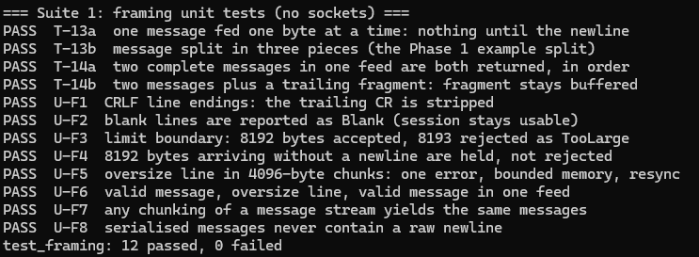

8.3.2 Unit and in-process protocol tests (34) and Integration tests over TCP (28)
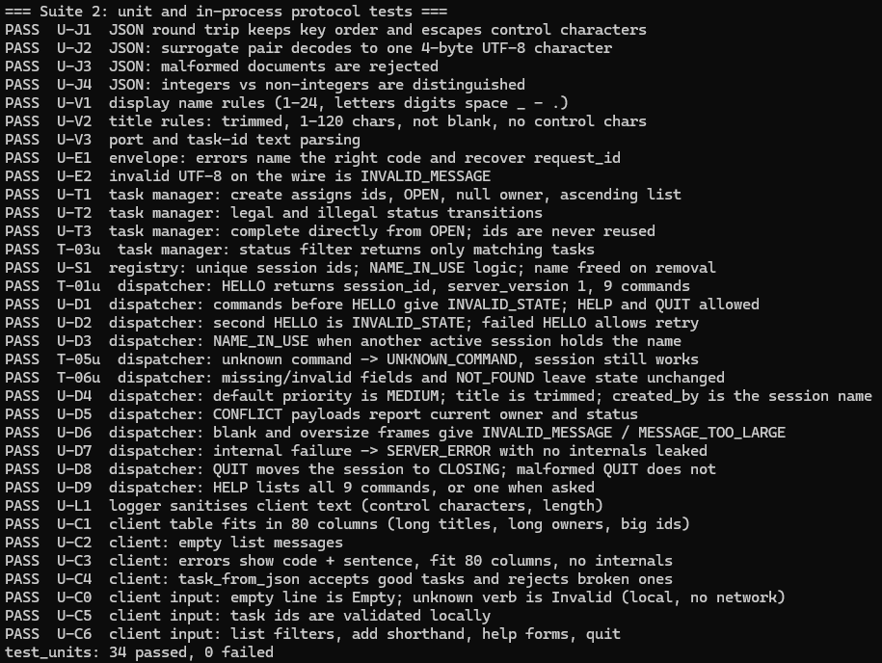

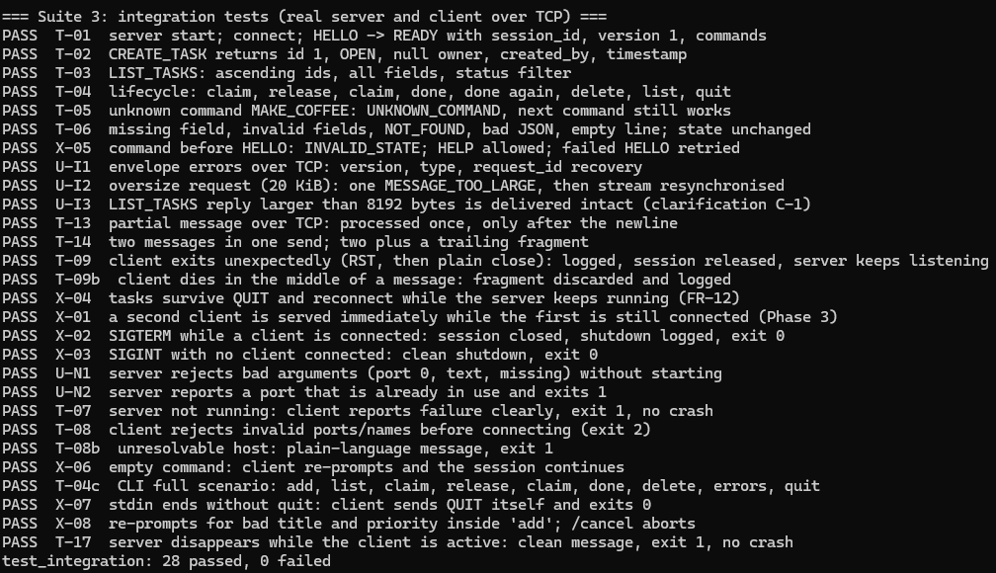

8.3.3 Manual checks
- M-01: Verify that the server responds in less than 100 ms. The slowest response time was 0.85 ms. Result: Pass.
- M-02 (NFR-09): Verify that the client reports a connection failure after its 10-second connect timeout when the address is unreachable. Corrected acceptance criterion: the failure is reported at 10.0 s plus at most 0.5 s of tolerance, because about 12-15 ms of start-up, name resolution and exit overhead always add to the 10-second wait. Result: the original run measured 10.013 s, and seven re-measurements on 2026-11-04 against unreachable addresses gave 10.012-10.015 s. Status: Pass against the corrected criterion.
- M-03: Verify that the client connects through 127.0.0.1, localhost and non-loopback addresses. All these connections were successful on the same computer. Status: Pass.
- M-04: Intentionally modify framing.cpp to check whether the tests will detect the bug. The tests detected it and all the tests have been passed after modification of the file. Status: Pass.

8.3.4 Phase 2 deferred tests:

- T-10: Check whether three clients can communicate at the same time and observe the changes. Status: tested in Phase 3 as C-01, C-02 and C-03. Success.

- T-11: Check whether two clients that must perform the same task are successful and create a conflict within 20 attempts. Status: tested as C-04 with 6 clients and 30 tasks, giving 30 OK and 150 CONFLICT and one owner for each task. Success.

- T-12: Check whether wrong data sent by one client affects the other ones. Status: tested as C-08 with invalid JSON, unknown command, missing field, invalid UTF-8 and line too long. Success.

- NAME_IN_USE: Check whether the server rejects the username that is used by another client. Status: tested with real clients as C-06 with 6 clients and one name, giving 1 OK and 5 NAME_IN_USE. Success.

8.3.5 Phase 3 concurrency and reliability tests (16)
ID | What it does | Result (all pass)
C-01 | Three clients connect and HELLO at the same moment | Three different session ids, log shows 3 active clients
C-02 | Three clients do three different operations at once: create list and claim | All OK, final list has 2 tasks
C-03 | Two clients create 40 tasks each at the same time | 80 unique ids, 1 to 80, none lost
C-04 | 6 clients race to claim the same 30 tasks | 30 OK, 150 CONFLICT, one owner per task
C-05 | One client deletes a task another is viewing | Viewer gets NOT_FOUND on its next action
C-06 | 6 clients HELLO with the same name at once | 1 OK, 5 NAME_IN_USE
C-07 | One client dies abruptly mid-message while two others work | Others keep working, name reusable after cleanup
C-08 | One client sends invalid requests while others work | Right error codes, others unaffected, bad session still usable
C-09 | 40 clean and 20 abrupt connect/disconnect cycles plus 40 parallel | Server healthy original client still served
C-10 | 3 clients each send 100 requests in one write | 100 replies each, in order, 300 tasks created
C-11 | Two clients send requests in 7-byte pieces | All requests answered correctly
C-12 | Three messages, one of them split, in one write on 3 clients | Three replies in order
R-01 | Missing data and invalid state transitions | NOT_FOUND, CONFLICT, INVALID_STATE as specified
R-02 | SIGTERM with 3 clients connected, as a graceful shutdown | All 3 closed and logged, exit code 0
R-03 | Restart on the same port | Accepts clients, task list empty because it has not persisted
R-04 | Four clients log at once | 100 success lines, every line complete

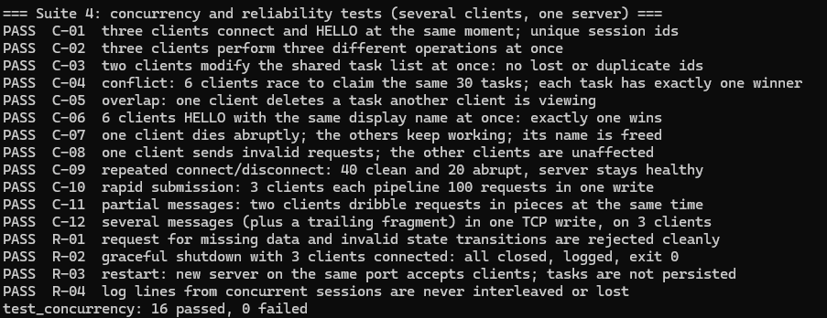

8.3.6 Load test results
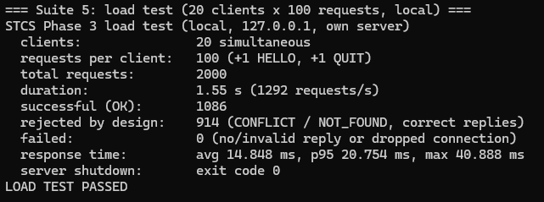

8.3.7 Extra checks
I compiled the server with -fsanitize=thread and ran suite 4 and the load test against it. ThreadSanitizer detected no data race. To show that the race was real, I deliberately removed the lock from claim_task. ThreadSanitizer then detected the race, but C-04 still passed because the race window is small. So a passing C-04 shows that the outcome is correct, and ThreadSanitizer shows that the lock is needed.

8.3.8 Final verification run and corrections
- Source defect in server/main.cpp. The SIGINT/SIGTERM handlers were installed after the server logged “Server listening”. A signal sent in that short window used the default action and killed the server instead of starting the graceful shutdown. The test harness reported “killed by signal 2”, which showed up as intermittent X-03 failures. Handler installation now happens before server.start(). Until the wake-up pipe exists, the handler ignores signals. No other source file was changed.
- Test timing in tests/test_integration.cpp and tests/test_concurrency.cpp. T-09b, C-07 and C-09 reconnected with the same display name as soon as they saw the disconnect log line or the QUIT reply. The server frees the name a moment later, at “session released” (section 3.5), so the reconnect could receive NAME_IN_USE. C-09 also waited for the exact text “active clients: 0”, which does not have to appear. The tests now wait for the “session released” line. This is a test change only. The server behavior is as documented.

8.4 Limits of the testing
- Framing unit tests can control exact chunk boundaries, unlike TCP tests, because the OS may combine small writes. Together, they check correctness at each level.
- FR-02 has been tested on a single machine: loopback, localhost and non-loopback local machine. No other machine was used.
- NAME_IN_USE needs two sessions open at the same time. Unit testing of this feature was done during Phase 2 (U-D3, U-S1) and live testing during Phase 3 (C-06).
- SESSION_ERROR is defined but never sent by the server (C-08), so there is no test for it.
- NFR-08 and NFR-09 features are manually tested using a few request cases.
- The load and concurrency tests were performed using one machine via loopback, so network bandwidth and actual network latency are not tested.

9. Design-change summary
The wire protocol is unchanged from Phases 1 and 2. The same framing, envelopes, nine commands, twelve error codes, session states and task model apply. No new fields, commands or error codes have been added. Phase 3 only changes the internals of the server. The twelve points below cover aspects that were left undefined in Phase 1, record decisions made during implementation and add minor changes to existing payload formats. Rows C-2, C-7, C-8 and C-9 were modified in Phase 3.
 | Final clarification / implementation | Reason / effect
C-1 | Server requests limited to 8 KiB client replies supported up to 1 MB. | Prevents large task-list responses, such as 60 tasks, from being truncated.
C-2 | Names: 1-24 ASCII characters case-sensitive uniqueness enforced under registry mutex. | Removes ambiguity and prevents duplicate active usernames during concurrent connections.
C-3 | Titles: 1-120 Unicode code points after trimming ASCII spaces reject control characters. | Defines character counting and validation precisely. No Phase 3 change.
C-4 | Return request_id and command whenever identifiable otherwise use null. | Clarifies error correlation without changing protocol behavior.
C-5 | Defined CLI commands: help, add, list, claim, release, done, delete, quit, raw. | Improves client-side usability only.
C-6 | Documented and standardized structured error details for UNKNOWN_COMMAND, INVALID_STATE and INVALID_VERSION. | Enables clients to interpret errors without parsing message text.
C-7 | Implemented thread-per-client concurrency instead of single-client handling. | Supports simultaneous clients without requiring a BUSY response.
C-8 | SESSION_ERROR remains defined but is never transmitted. | Existing termination paths already handle session closure.
C-9 | Sequential hexadecimal IDs in the format sess-%04x, such as sess-0001, sess-0009 and sess-000a, generated under registry mutex. | Ensures unique, readable session identifiers.
C-10 | Server accepts an optional log path, which is logs/server.log by default executables are bin/server and bin/client. | Improves logging flexibility and standardizes execution.
C-11 | Ignore unknown fields, reject duplicate JSON keys and limit nesting to 32 levels. | Improves input validation and parser robustness.
C-12 | Server sends no unsolicited messages shutdown closes sessions and clients detect connection closure. | Preserves the one-request/one-reply protocol model.

10. Scalability analysis

Topic | Key findings | Improvement
10-100 clients | 10 clients: 1 ms average response, no failures. 100 clients: 51 ms average, 173 ms p95, no failures. | Optimize task locking and paginate LIST_TASKS.
Concurrency bottlenecks | Single TaskManager lock serializes requests list operations copy all tasks. | Reader-writer or per-task locks consider data sharding.
Memory and threads | About 24 KB resident memory per idle client, measured as 23.7-24.0 KB at 100, 250 and 500 idle clients that had sent HELLO. 500 clients use 501 threads. Each client thread also reserves about 10 MB of virtual address space on average, mainly the default 8 MB stack. This is reserved virtual memory, not resident RAM. | Thread pool, smaller stacks or non-blocking epoll event loop.
Logging overhead | Synchronous file and console write under one mutex a blocked console reader can stall all clients. | Buffered/asynchronous logging and configurable log levels.
Network bandwidth | About 150 bytes per task as an estimate: 1,000 tasks produce about 150 KB. Measured: a task with a 26-character title takes 161 bytes, so the 1 MB reply limit is reached at about 6,500 tasks longer titles lower it. | Pagination, filtering and compression.
Data persistence | Tasks are stored in memory and lost after server restart. | SQLite/PostgreSQL or an append-only log.
Single-server failure | One process handles all clients and a crash disconnects everyone. | Process supervision, persistence and standby server.
Large-scale deployment | Thousands of users require better concurrency, authentication, TLS, rate limiting and health monitoring. | Load balancing, multiple servers, shared database and message queue.

11. Known limitations
- One thread per client. Suitable for tens to hundreds of clients, not thousands (see Section 10).
- No persistence yet. Tasks live in server memory and are lost if server exits (FR-27 future work).
- IPv4 only. No authentication, display names used only for identification (NFR-15).
- No shutdown message. Clients connecting during shutdown receive the closed connection notice (C-12).
- Partially validated multi-machine. FR-02 was tested on a single machine.
- The client provides local command help after connecting and completing HELLO. Server-specific protocol help is available through help server [COMMAND]. Pre-connection help is not currently supported.
- One lock per shared area, so clients queue under load and LIST_TASKS copies all tasks (see Section 10).
- No server push. Changes by other users appear after the next list. A viewer acts on obsolete information and receives CONFLICT or NOT_FOUND responses.
- Console logging can stall when the output pipe is full, because the log lock is held while writing (see Section 10).
- No idle timeout and no client limit. An idle client holds a thread (see Section 10).
- Tests for concurrency do not prove absence of races. ThreadSanitizer did not find any, but it is only able to check tested paths.
- The display name is released just after the QUIT reply is sent or after a dropped connection is detected, not before. A client that reconnects with the same name in that instant can receive NAME_IN_USE once and must retry.

12. Team contribution summary
This is an individual project. Sai Praneeth Bhattu completed all protocol design, implementation, testing and documentation.

13. Ripple Report Reflection
Part A: What users see and experience
- Most important rule: the first claim wins. The first user to claim a task becomes the owner, and other users get a CONFLICT response that names the owner. In the test with 6 clients and 30 tasks, each task got exactly one owner (C-04).
- Best choice for reliability: one thread per client, with each session kept private to its thread, and careful error handling. The task list, session registry and logger are shared, but each is protected by a mutex. If one client dies or behaves badly, the others are not affected (C-07, C-08).
- Hardest thing to understand: the list on the screen is static. Users need to refresh the list to learn about updates made by other users, and acting on a stale view can result in CONFLICT or NOT_FOUND.
- Error handling and trust: every error has a code and a short message that explains the cause, such as who now owns the task. There are no stack traces, and the client is still usable after every error.
- Incorrect assumptions: I assumed the screen view is live. In test C-05, a task was deleted but was still visible to another client. Another incorrect assumption was that a passing test means the lock is correct (section 8.3.7).
- Test results: no duplicate claims in the race tests, 0 failed requests with 100 clients, and clear errors for all stale or invalid requests.

Part B: Effects on teammates
It is a solo project, so a teammate here means myself. Correcting the protocol and its framing in Phases 1 and 2 meant that Phase 3 did not need any changes to the client or the shared code, so development could go step by step and safely. The protocol rules and the numbered test plan, with T-, U-, X-, C- and R- ids, helped me start working without re-reading the code. Some rework came from ideas that did not fit in Phase 2. There was the idea of a “session_lock”, which was changed to the SessionRegistry mutex in the final version. T-10 to T-12 were moved to later and had to be implemented. I considered one thread per client, a thread pool and an epoll loop, and chose the smallest change that covered the checklist. Next time I would write the concurrency tests and run ThreadSanitizer before adding locks, so that each lock is justified by a failing check.
Part C: Effects of networking decisions
Message framing. The server accepts messages as lines, each with one JSON object. This format is human-readable and easy to test manually. The framer handles partial and merged reads, as tests C-10 to C-12 show. Because messages are separated only by newline characters, there is a limit of 8192 bytes per message and a separate limit of 1 MB for client replies (C-1). A future version could add message length prefixing or pagination of large lists.
Concurrency model. The server uses one thread per client, which lets me reuse the session loop from Phase 2. It also means one client does not block another (C-07). On the other hand, every client gets its own thread stack and the server enforces no fixed client limit, so the practical capacity depends on system resources, and latency grows noticeably after about 50 clients. A future version could use a thread pool with epoll, a client limit and an idle timeout.
Synchronization. Every shared object is protected by one mutex. This is the simplest option, and it avoids deadlocks because there are no nested locks and all task claims are atomic. The drawback is that every request is serialized, and LIST_TASKS has to copy the entire task list while holding the lock. A future version could use a reader-writer lock or per-task locks and move shared state into a database.
Part D: Scale reflection
See Section 10, Scalability analysis, for the differences between 10 and 100 clients, their bottlenecks and possible improvements. My priorities are reliability and persistence first, because a failure or shutdown of the service loses all tasks. Next comes performance, such as an event loop or threads, paginated lists and reader-writer locks. After that comes security, such as authentication and TLS. Monitoring, a process supervisor and a failover server are also being considered. Accessibility is outside the current project scope.

Part E: Use of AI tools
Three different AI tools were used are UMGPT, Claude, and Gemini. All these tools were useful for various purposes.

- UMGPT: Primarily used for technical explanations, networking and for implementing certain parts of the program.

- Claude: Most useful for handling the hardest parts, mainly Phase 3 Concurrency. Helped me understand the implementation of the mutex lock, the while loop that allowed accepting only one client at a time, concurrency and reliability testing cases creation, testing code, and load testing.

- Gemini: Secondary tool for finding additional information and solutions.

Individual reflection
I did all the development of this project by myself, including the protocol, implementation, tests, load test, diagrams and this write-up. The networking concept that mattered most to me in this assignment is that TCP organizes bytes only within a single connection. The server needs to make decisions about conflicting requests coming from several clients, and this is done with a lock. The biggest difficulty for me during the implementation was the load test that hung. The server was blocked while writing to a full console pipe with the log mutex held, and this showed me that logging is another piece of shared state. I would like to learn more about non-blocking I/O with epoll and measuring memory and latency under heavier loads. The main benefit of my work is the conflict rules and their tests.

